Weak Efficient Market Hypothesis Analysis of the Nigeria capital market

Ajaegbu Ebuka Emmanuel (2021)

1ajaegbu35@gmail.com

3ebukaajaegbu35@gmail.com

**1. Introduction**

Frank (2012). In an efficient capital market, security prices adjust quickly to the release of new information into the markets, therefore prices of security reflects all available public information about that security. At any point in time in an efficient market, the security price that prevails is an unbiased reflection of all currently available information, including risk involved in owning the security. In an efficient markets past rate of returns are independent of future rate of return, therefore it is impossible to generated a risk adjusted return above the market benchmark. A passive strategy is the best portfolio management strategy in this market.

Fama (1965) believed that beating the market based on risk adjustment only in an efficient market will not only be difficult but impossible since the prices of the assets or security will adjust to new information. The information not only reflect what is currently known but also future expectations such as earnings or dividends.

Fama (1970) categorized the EMH hypothesis into three broad categories the

a) Weak,

b) Semi weak and

c) The strong Efficient Market hypothesis.

**a) Aim/Objectives:**

i) This research is conducted to test if the Nigeria Capital Market is weak form Efficient or Not.

ii) To determine if an active portfolio management strategy or the passive portfolio strategy is best in the Nigeria Capital Market.

**b) Data:** The NGSEASI spanning January 2019 to January 2021 was used. NGSEASI is an index that tracks all security on the Nigeria Capital Market.

The weak-form EMH assumes that current stock prices fully reflect all security market information, including the historical sequence of prices, rates of return, trading volume data, and other market-generated information, such as odd-lot transactions and transactions by market-makers.Because it assumes that current market prices already reflect all past returns and any other security market information, this hypothesis implies that past rates of return and other historical market data should have no relationship with future rates of return (that is, rates of return should be independent). Therefore, this hypothesis contends that you should gain little from using any trading rule which indicates that you should buy or sell a security based on past rates of return or any other past security market data.

**2. Statistical test of Independence for Weak Efficient Market Hypothesis**

Frank (2012) the EMH contends that security returns over time should be independent of one another because new information comes to the market in a random, independent fashion, and security prices adjust rapidly to this new information. Two major statistical tests have been employed to verify this independence.

First, autocorrelation tests of independence measure the significance of positive or negative correlation in returns over time. Frank (2012). Several researchers have examined the serial correlations among stock returns for several relatively short time horizons including 1 day, 4 days, 9 days, and 16 days

Secondly non parametric run test can be used to test the assumption of independence of the rate return

**Serial Correlation Test**

**Hypothesis**:

H0: There is no serial correlation: The stock market price follows the random walk theory

H1: There is serial correlation: The stock market does not follow the random walk theory

**• Ljung Box Test**

Ljung Box is used to test for serial correlation in time series, it test to determine whether a series of observations over time are random and independent. The hypothesis of serial correlation will be accepted if the p value is less than the level of significance.

The test statistics is as follows

Q = n (n +2) Σ𝑝𝑘2 / (n-k)

**Run Test**

**Hypothesis:**

H0: The sequence is a random sequence: The rate of return are independent

H1: The sequence is not a random sequence: The rate of return are not independent.

The runs test is a non-parametric test used to determine if the sequence of data follows a random process. The run test is based on the number of runs occurring in within the sample, the runs is the sequences of change in the return of the series. Given a series of price changes, each price change is either designated a plus (+) if it is an increase in price or a minus (−) if it is a decrease in price. The result is a set of pluses and minuses as follows: + + + − + − − + + − − + +. A run occurs when two consecutive changes are the same; two or more consecutive positive or negative price changes constitute one run. When the price changes in a different direction, such as when a negative price change is followed by a positive price change, the run ends and a new run may begin. To test for independence, you would compare the number of runs for a given series to the number in a table of expected values for the number of runs that should occur in a random series.

**3. Evaluation**

**a) EDA**

Table of the Descriptive Analysis of the Daily Return of the Nigeria All Share Index

|  |  |
| --- | --- |
| **Statistics** | **Value** |
| Observations | 506 |
| Minimum | -0.0506429 |
| Median | 0.0000416 |
| Arithmetic Mean | 0.0005466 |
| Geometric Mean | 0.0005004 |
| Maximum | 0.0382869 |
| SE Mean | 0.0004277 |
| LCL Mean (0.95) | -0.0002937 |
| UCL Mean (0.95) | 0.0013869 |
| Variance | 0.0000926 |
| Stdev | 0.0096209 |
| Skewness | -0.0501728 |
| Kurtosis | 4.1539874 |

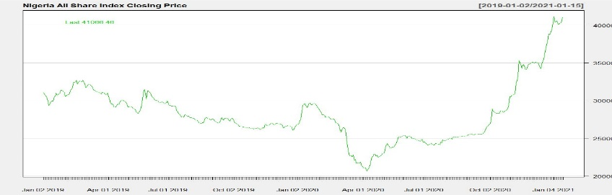

*Figure1: The closing Stock Price of NGSEASI*

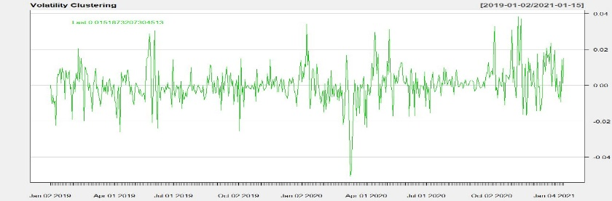

*Figure2: The Volatility Clustering: The daily return of NGSEASI*

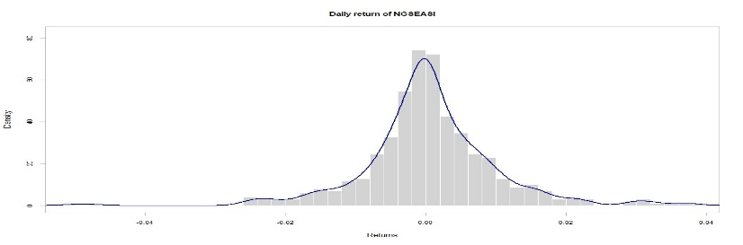

*Figure3: The density of the daily return of NGSEASI*

It is observed that all the markets have a positive return during the period considered in the study as ascertained by the values of Arithmetic mean and a compounding/Geometric mean average. The upward trend in the stock price overtime is ascertained graphically in the time series plot in Figure 1. The highest and the lowest returns recorded in the period is determined by the Maximum and the Minimum statistical values. The risk is determined by the value of standard deviation of the distribution. The negative skewness and high kurtosis value (above the normal distribution of skewness of 0 and kurtosis of 3) indicate that the distribution of the return is asymmetrical (i.e. it is tailed to the left and leptokurtic). The distribution is graphically presented in the Figure 3 in the density plot which visually determines that the distribution of the return is not normally distributed.

**b) Weak Efficient Market Hypothesis.**

**i) Serial Correlation Test**

We will be considering relatively short period lag1, 4, 9, and 16.

Ljung Box test for serial correlation

|  |  |  |  |  |
| --- | --- | --- | --- | --- |
| Statistics | Lag1 | Lag4 | Lag9 | Lag16 |
| X – squared | 61.742 | 101.4 | 118.3 | 134.7 |
| P value | 3.886e-15 | < 2.2e-16 | < 2.2e-16 | < 2.2e-16 |

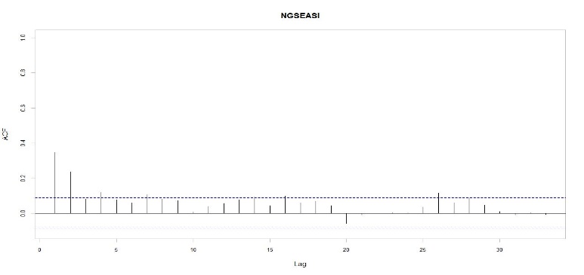

*Figure4: The Autocorrelation Function of NGSEASI returns*

As presented in the table above, at 5% level of significance the null hypothesis of no serial correlation was rejected for lag 1, 4,.9 and 16. The P-Values are less than the level of significance, Therefore there is the presence of serial correlation in the daily returns. As confirmed by the Autocorrelation plot (figure 4) there is a significant spike at lag 1,4, and 16, although the spike at lag 9 does not cross the bound. The return does not follow a random walk

ii) **Run Tests**

|  |  |  |  |
| --- | --- | --- | --- |
| Statistics | Test value | Runs | P value |
| Value | -4.9839 | 198 | 6.23e-07 |

As presented in the table above, at 5% level of significance the null hypothesis of random sequence was rejected. The P-Values are less than the level of significance, therefore the returns does not follow a random sequences.

**4 Conclusion**

This study aim to determine the information efficiency of the Nigeria capital, the Nigeria All share index was tested for weak EMH. The test for independence was adopted in this research. The parametric serial correlation test and the non-parametric runs test was used to test the hypotheses of randomness or random sequences which was rejected at 5% level of significance. It implies that the returns of the NGSEASI is not independent and therefore the weak form efficient market hypothesis of the Nigeria Capital market was rejected.

The Nigeria capital market is not weak form efficient. The prices of stocks in Nigeria market does not reflect all available market information. Past prices of securities could be used to devise a trading strategy that can predict future trends in the price movement of the security. It is therefore possible generate a risk adjusted return that is above the market benchmark by adopting an active approach to portfolio management.

**REFERENCES:**

[1] Fama, E. F. (1965). Random Walksin Stock Market Prices. FinancialAnalysts Journal, 51(1), 75-80.http://doi.org/10.2469/faj.v51. n1.1861

[2] Fama, E. F. (1970). Efficient capital markets: A review of theory and empirical work. *The Journal of Finance, 25*(2), 383-417.

[4] Frank K Reilly , Keith C Brown(2012). Investment Analysis and Portfolio Management.

**Author:**



Ebuka .E. Ajaegbu is a graduate of statistics from the federal university of technology Owerri, he is an Education Consultant, researcher, data scientist and financial analyst. He love to apply statistics, machine learning to Finance.

Contact:

Whatsapp: +234-8131355153

Email: ajaegbu35@gmail.com